f

[Subject]

[Title]

Date of Issue: [Publish Date]
Version #: [Abstract]
Author: Pavel Aleman

Table of Contents
Table of Contents 2
Self-serve BI & Data Analytic Architecture within MS Fabric Change Control & Distribution Log 3
Self-serve BI & Data Analytic Architecture within MS Fabric Roles and Responsibilities 3
Introduction 7
Scope 8
Roles & Responsibilities 9
Domain Teams 9
Tenant/Enablement Team 9
Incident Mgmt. Process Flow. 9
Incident Management Process 11
Step Domain-1: Incident Triage at Domain Level 11
Step Domain-2: Domain-Level Resolution 11
Step Tenant-1: Tenant-Level Resolution 12
Step Tenant-2: Communication & Closure 12
Performance Degradation Management 12
Domain Performance Incident 12
Tenant Performance Incident 12
Escalation Path 12
Appendix: 14
Fabric Enablement Team Composition and Accountabilities 14

[Subject] Change Control & Distribution Log
Version, Date & Author | Purpose | Description of Change and Distribution
Version: 0.1  Date: September 9, 2025  Author(s): Pavel Aleman | Input | Initial version of document leveraging Exchange SAD
Version: 1.0  Date: October 10, 2025  Author(s): Pavel Aleman | Input | Request to input members to provide feedback on sections important to them.

[Subject] Roles and Responsibilities
Role | Assign To
Recommend  (Individual or group accountable for producing the deliverable) | Pavel Aleman, Enterprise Architect
Approve  (individual or group accountable for approving this document | DDS Architecture Review Board (ARB)  Hajer Zaiem, Director  Louis Bergeron, Director
Concur  (individuals or groups asked to support and endorse the contents of the deliverable) | Richard Dea AD, Business Intelligence and Insights - DDS  Dylan Spevack-Willcock, Manager, Information Governance and Standards - DDS
Input  (individuals or groups asked to provide views, requirements and information to the deliverable and may be actively involved in producing the deliverable) | Paul Guibord, Assistant Director, SAP and AI tooling  Charlie Alswiti, Solution Architect  Ramesh Paskarathas, Principal Analyst  Ivan Araujo, Business Analyst  Agnes Wong, Metadata and Standards Analyst
Notify  (individuals or groups notified of the deliverable) | Leadership Team  Project Team  Self-serve Data Domains of Triton, DAS, IMPACT  All of the above (R, A, C, I)

Incident and Performance Mgmt. Process.
Self-serve BI & Data Analytic Architecture within MS Fabric
Executive Summary
The Incident and Performance Degradation Management Process defines how the Fabric Enablement Team and Business Data Domain Teams collaborate to maintain the reliability and performance of the Bank of Canada’s Microsoft Fabric Data Platform. Operating within a Managed Self-Service Data Mesh model, it establishes clear responsibilities for incident detection, triage, escalation, and resolution across Domain and Tenant layers. The process aligns with the Bank’s enterprise ITSM practices, ensuring security, compliance, and operational excellence while enabling domains to remain autonomous. This coordinated model strengthens trust, resilience, and agility across the Bank’s data and AI ecosystem
Extended Executive Summary
The Incident and Performance Degradation Management Process defines how the Fabric Enablement Team and Business Data Domain Teams collaborate to maintain service continuity, ensure performance reliability, and sustain trust in the Bank of Canada’s Managed Self-Service Data Platform on Microsoft Fabric. This process introduces a two-layered operational model:
- Domain Layer — business-owned workloads, managed and monitored by Domain teams.
- Tenant Layer — centralized services, capacities, and tenant-level configurations governed by the Fabric Enablement Team.
Through a standardized escalation path and well-defined accountability model, incidents and performance degradations are detected, validated, and resolved efficiently, minimizing business disruption while preserving autonomy within each domain.
The process complements — not replaces — the Bank’s enterprise Incident Management Process, ensuring alignment with corporate service management practices (SNOW) and integrating Fabric-specific operational insights and diagnostics.

Mission Statement
To ensure reliability, performance, and resilience of the Microsoft Fabric data platform while empowering business domains with managed self-service capabilities that accelerate innovation and maintain governance integrity.

Vision Statement
To establish a trusted, self-regulated, and high-performing Fabric environment where business domains operate with confidence and autonomy — supported by a proactive enablement function that bridges business and platform operations through governance, automation, and collaboration.

Introduction
The Fabric Enablement Team plays a critical role in maintaining the operational integrity of the Bank’s Microsoft Fabric Data Platform, which enables decentralized data ownership and managed self-service analytics across multiple business domains.
This document provides the framework for managing incidents and performance degradations within the Fabric environment. It defines the process for detection, triage, validation, escalation, and resolution of issues impacting data analytics workloads — including data ingestion, transformation, modeling, serving, and visualization — whether occurring at the domain level or within the Fabric tenant infrastructure.
The process ensures that:
- Business domains retain responsibility and agility in managing their own workloads and data products.
- The Fabric Enablement Team safeguards the platform’s overall health, capacity stability, and governance compliance.
- Both layers work in coordinated response when issues arise, ensuring that escalation paths are clear, response times are met, and performance metrics are continuously monitored.
By formalizing this structure, the organization reinforces its commitment to operational excellence, proactive monitoring, and transparent communication — essential for scaling Microsoft Fabric as a strategic enterprise data platform.

Scope
- This process applies to all incidents affecting data analytics workloads hosted in Fabric domains, including data ingestion, transformation, modeling, serving, reporting, and performance degradation of jobs or queries.
- This document does not replace the organization’s official Incident Management Process; it serves as a specialization and annex tailored to the Managed self-service model implemented on Microsoft Fabric, focusing on the distinction between Business Data Domain-level and Tenant-level responsibilities.
- Once a Domain team escalates an incident to the Fabric Enablement team or requests escalation to Microsoft Support, the Domain team:
  - Must remain available including both technical and decision-making resources, allocated in according to the severity level of the escalated incident, for the duration of the support process as required by either BoC Fabric Enablement team or Microsoft support
  - Must provide all relevant incident description, factual evidence and access to the data artefacts reported, leveraging the monitoring tools provided to the Domain.
  - Must ensure that all calls with Microsoft Support for troubleshooting include members of the Fabric Enablement team.
- Fabric Enablement Team’s response times will be based on the established SLA; currently defining MS Fabric data platform as an Application with Standard SLA, 2 – 48 hours RTO, depending on incident severity.

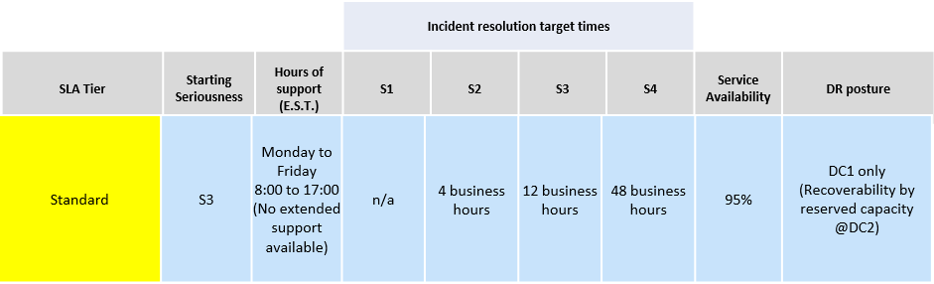

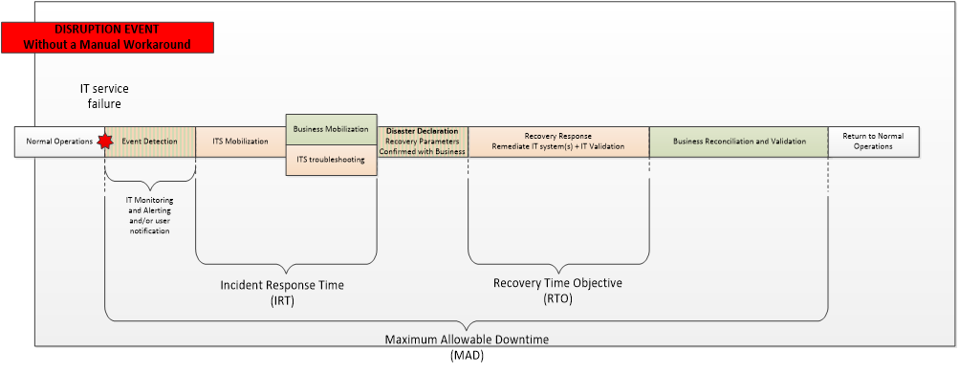

Roles & Responsibilities

Domain Teams
Scope: Own and support incidents of domain data products and domain data processes, like Git integration.
Responsibilities:
- Perform incident triage to validate whether the issue is domain-specific or should be escalated.
- Diagnose and remediate data process and data solution-level issues (e.g., inefficient queries, failed pipelines).
- Provide evidence when escalating incidents to the Fabric Enablement team.

Tenant/Enablement Team
Scope: Own and support incidents at the Tenant and Capacity configuration, services and performance.
Responsibilities:
- Own and support Fabric tenant, shared capacities, and platform services.
- Investigate platform-level failures (capacity malfunction, tenant configuration errors).
- Coordinate with Microsoft or cloud providers.
- Communicate cross-domain impact and resolution status.

Incident Mgmt. Process Flow.

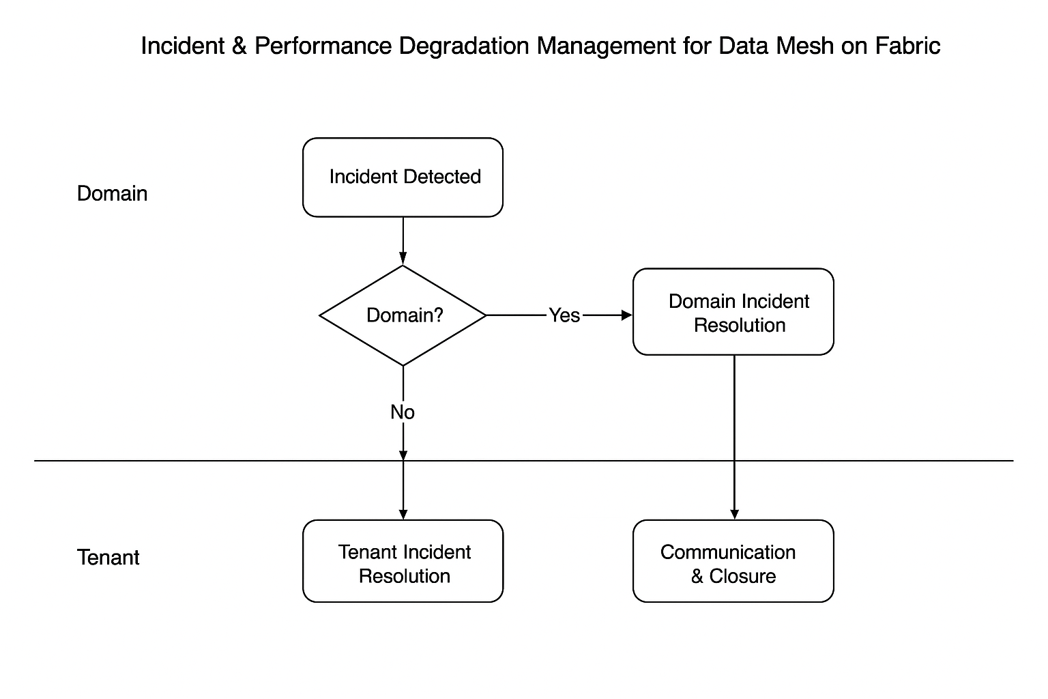
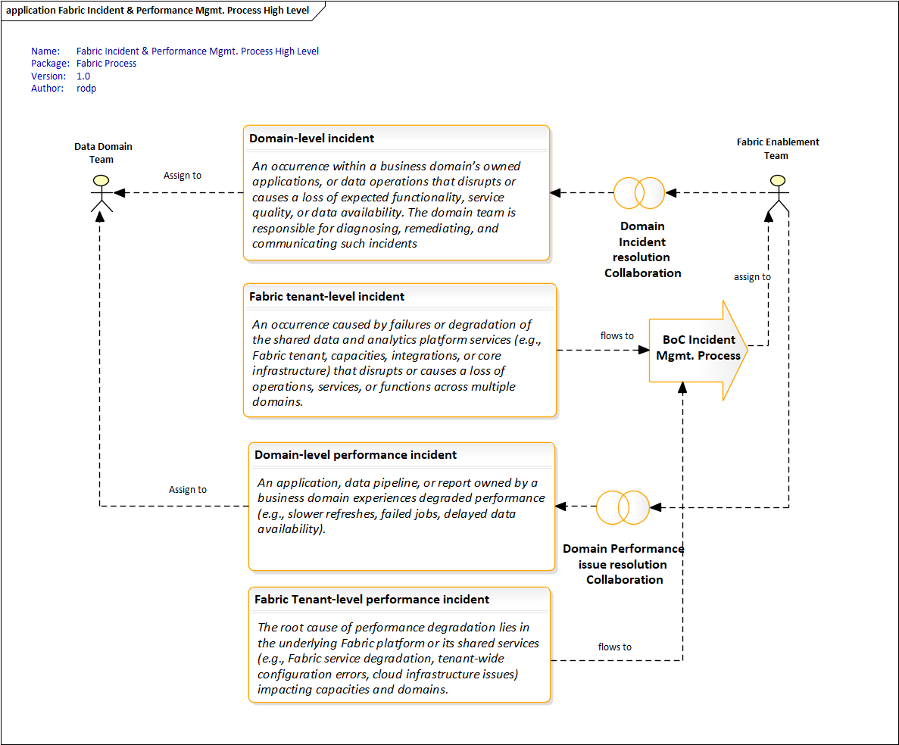

Incident Management Process

Step Domain-1: Incident Triage at Domain Level
- Incident detected and documented by Domain members (monitoring, user report, alert).
- Domain validates if issue is real and impacting Domain service.
- Decision: If domain-related → domain resolution. (recommended to capture the incident in SNOW)
If suspected tenant/platform → escalate the documented incident using our Service Mgmt. Platform SNOW.

Step Domain-2: Domain-Level Resolution
- Root cause analysis of pipelines, queries, data models, or scheduling.
- Apply remediation and validate recovery.
- Notify affected users.
- If unresolved → escalate to Tenant.

Step Tenant-1: Tenant-Level Resolution
- Investigate Fabric capacity/tenant health.
- Validate if multiple domains are impacted.
- Apply remediation or coordinate vendor support.
- Communicate resolution status.

Step Tenant-2: Communication & Closure
- Document root cause and resolution.
- Notify impacted stakeholders.
- Close incident records in SNOW and/or Microsoft Support.

Performance Degradation Management

Domain Performance Incident
- Symptoms: slow pipelines, delayed refreshes, inefficient queries, poor report performance.
- Responsibility: validate solution design and remediate where possible.
- Provide evidence enough to reproduce the incident if escalating the incident to Fabric Enablement Team.

Tenant Performance Incident
- Symptoms: cross-domain slowdowns, capacity queuing, tenant-wide degraded responsiveness.
- Responsibility: validate capacity utilization and tenant health, investigate contention or malfunction, and escalate to Microsoft if needed.

Escalation Path
- Domain Triage by Domain Team → Domain Resolution, if root cause is workload.
- Domain Triage by Domain Team → Escalation to Fabric Enablement Team, if platform issue suspected or multiple domains impacted.
- Tenant Resolution by Fabric Enablement Team → Coordinate, remediate, communicate with Domains
- Tenant Escalation by Fabric Enablement Team → Microsoft Escalation if necessary.

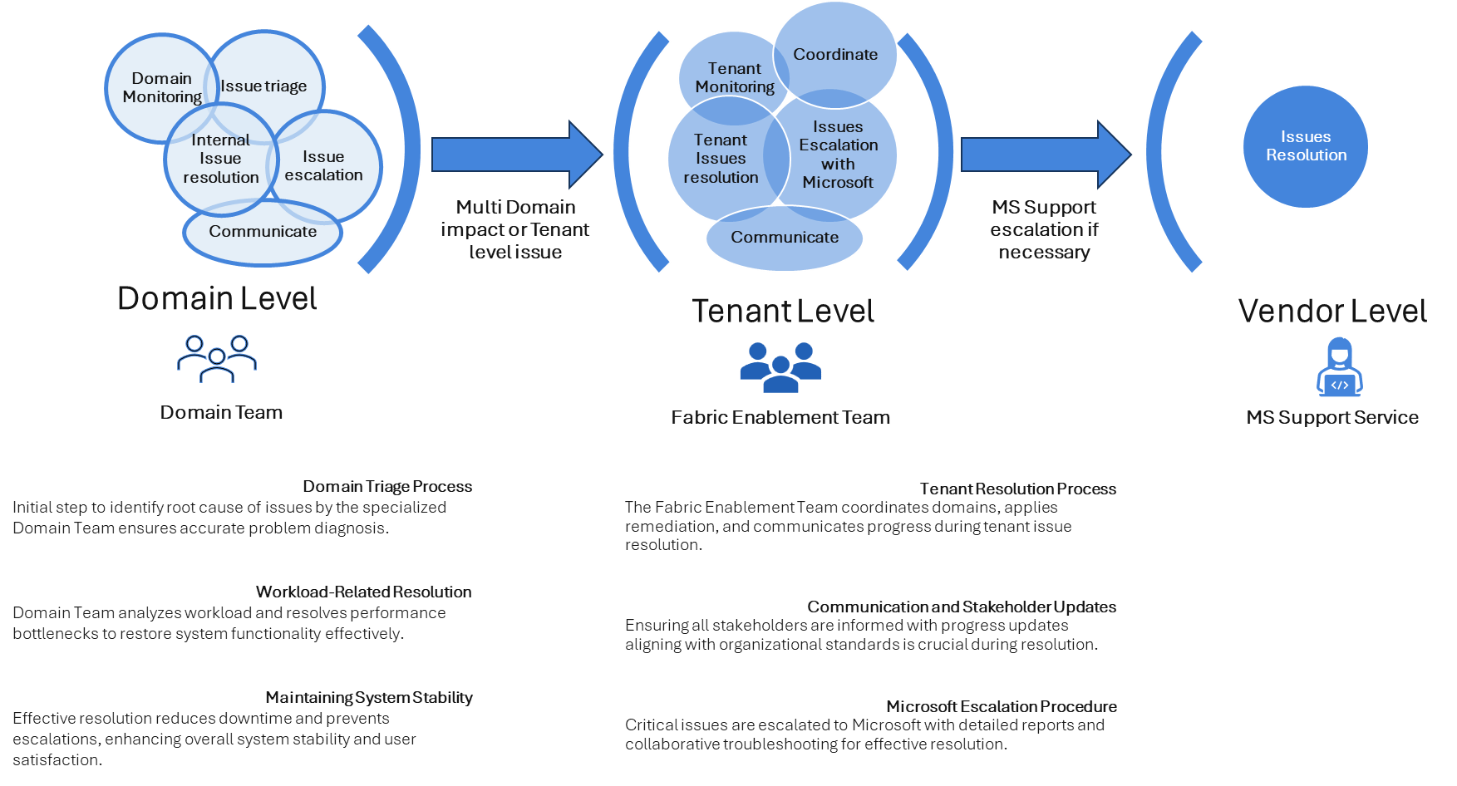

Appendix:

Fabric Enablement Team Composition and Accountabilities
The Fabric Enablement Team is responsible for managing and governing Microsoft Fabric at the Tenant, Capacity, and Governance & Policy levels. The team ensures the platform is secure, compliant, performant, and aligned with enterprise architecture standards while enabling self-service and federated data ownership across domains. The image below shows the composition of the Fabric Enablement Team. More information can be found here

